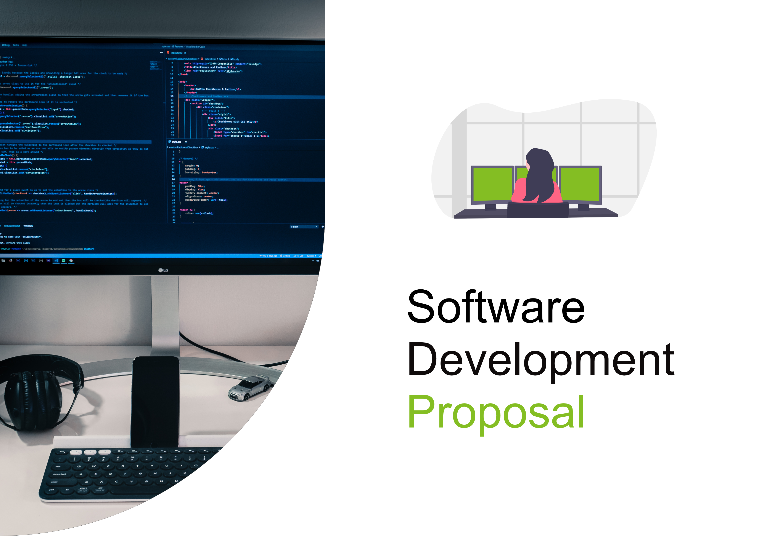
1. Overview

The presented proposal outlines the development of a proprietary, intranet-only dashboard featuring up-to-date information regarding the health status of all monitored devices in Daikibo's four factories (nine machines each). Specifically, the proposed solution would be a one-page website available via the company’s internal network only. The login mechanism of the system is to be integrated with the client’s authentication server so that employees would be able to authenticate using the same account credentials on the internal corporate network. The design of the dashboard is to feature the current device statuses in an expandable list by factory and by machine with a history section.

2. Scope

The dashboard will have the following features:

- Live machine health status shows the current status (Operational, Warning, Critical) of all 9 machines in each of the four factories using color coding.
- Hierarchical view (expandable and collapsible): Users will be able to collapse or expand entire factories to show or hide the status of all the machines within that factory. Each machine may also be expanded to see its status history.
- Status history: Each machine would have its status history which would contain time stamps and previous statuses. This data would be taken from historical telemetering data.
- Access Authentication: Access to the dashboard would be authenticated using the client's internal LDAP/Active Directory server. Unauthenticated attempts would be rejected while authenticated intranet access would have read-only permissions.
- Intranet deployment: The application would be deployed within the client's intranet infrastructure (IIS/Apache) using HTTPS connections.
3. Estimate

Total man‑hours: 120 hours
Category | Hours
Development (frontend + backend) | 80
Testing (unit + integration) | 12
Testing (unit + integration) | 28

Detailed breakdown:
Requirements & design: 20 h
Frontend development (collapsible UI, history panels): 45 h
Backend API development: 25 h
Authentication integration (LDAP/AD): 10 h
Testing & QA: 12 h
Deployment & intranet configuration: 8 h
4. Timeline

- [1st of September] Design starts: Wireframes, technical specifications, and authentication flow design.
- [8th of September] Backend & integration: API development, telemetry data ingestion, LDAP authentication integration.
- [22nd of September] Frontend development: Single‑page dashboard, collapsible factory/machine views, history panels.
- [6th of October] Testing: Functional testing, security testing (intranet only), load testing.
- [13th of October] Deployment to staging: Internal user acceptance testing (UAT) within intranet.
- [20th of October] Production go‑live: Final deployment to production intranet environment.
Total duration: 7 weeks (assuming 5‑day work weeks).

5. Support
We provide continuous post‑launch support to ensure the dashboard remains reliable and secure within Daikibo’s intranet. Our support includes:
- Bug fixes: Priority resolution for any defects discovered within 30 days of go‑live, followed by standard next‑business‑day response for critical issues.
- Support tickets: Access to a dedicated support portal for technical questions, configuration changes, and troubleshooting.
- Ongoing maintenance: Security patches for dependencies, authentication protocol updates, and performance monitoring.
- New functionality: Ability to extend the dashboard (e.g., additional factories, export history, alert rules) on a time‑and‑materials basis or via a separate maintenance agreement.

